Caruthersville Public Library
Sunday Movies at the Library

February 4, 2018 – “Betty and Coretta
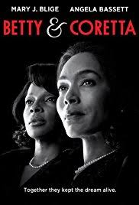
After the assassinations of Dr. Martin Luther King Jr. (Malik Yoba) and Malcolm X (Lindsay Owen Pierre), their widows, Coretta Scott King (Angela Bassett) and Betty Shabazz (Mary J. Blige), continue to raise their children and fight for the cause.

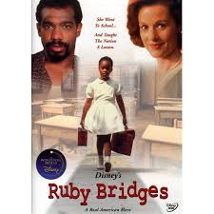
February 11, 2018 – Disney’s “Ruby Bridges”
This film presents the real-life tale of young Ruby Bridges (Chaz Monet), one of the first African-American children to attend an integrated school in the Deep South. At only age 6, Ruby is selected to attend an all-white school in New Orleans, causing an uproar in the racially divided region. Among the people who try to help Ruby adjust to the tense situation are teacher Barbara Henry (Penelope Ann Miller) and Dr. Robert Coles (Kevin Pollak), a child psychiatrist.
February 18, 2018 – CLOSED for Presidents Day
February 25, 2018 – “The Rosa Parks Story”
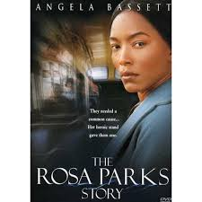
This biopic tells the story of civil rights activist Rosa Parks (Angela Bassett) from her days as a private-school student to her public battle against racism and segregation. As a secretary for the NAACP, Parks defends local children who have been victimized by racism. But when she is arrested after refusing to give up her bus seat for a white passenger, Parks inspires the 1955 Montgomery Bus Boycott.
Doors open at 1:00 and the Movies start at 1:30
The only ticket needed is your valid Caruthersville Public Library card

