Sunday Movies at the Library
January 2019
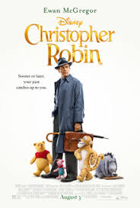
January 6 – “Christopher Robin”
Christopher Robin -- now a family man living in London -- receives a surprise visit from his old childhood pal, Winnie-the-Pooh. With Christopher's help, Pooh embarks on a journey to find his friends -- Tigger, Eeyore, Owl, Piglet, Rabbit, Kanga and Roo. Once reunited, the lovable bear and the gang travel to the big city to help Christopher rediscover the joy of life.

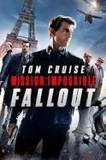
January 13 – “Mission Impossible – Fallout”
Ethan Hunt and the IMF team join forces with CIA assassin August Walker to prevent a disaster of epic proportions. Arms dealer John Lark and a group of terrorists known as the Apostles plan to use three plutonium cores for a simultaneous nuclear attack on the Vatican, Jerusalem and Mecca, Saudi Arabia. When the weapons go missing, Ethan and his crew find themselves in a desperate race against time to prevent them from falling into the wrong hands.

January 20 – LIBRARY CLOSED – Martin Luther King Day

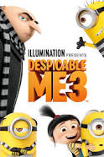
January 27 – “Despicable Me 3”
Special event sponsored by the Assembly of God Church – All Children attending will receive a free Minion toy.
The mischievous Minions hope that Gru will return to a life of crime after the new boss of the Anti-Villain League fires him. Instead, Gru decides to remain retired and travel to Freedonia to meet his long-lost twin brother for the first time.

Doors open at 1:00 and the movie begins at 1:30
The only ticket needed is your Caruthersville Public Library card.

